PHASE 6
Project Testing

Test Cases
ID | Test Case | Input | Expected Output | Result
TC01 | Register API | Valid name, email, password | User created, 201 response | Pass
TC02 | Login API | Valid registered email & password | JWT token returned, 200 response | Pass
TC03 | Login API | Invalid password | 401 Unauthorized error | Pass
TC04 | Workout CRUD | Add/Update/Delete workout log | Workout persisted/updated/removed correctly | Pass
TC05 | Stats API | Valid JWT, existing logs | Aggregated weekly/monthly stats returned | Pass
TC06 | AI Insight API | Valid workout data + JWT | AI-generated summary & recommendation returned | Pass

Bugs Found and Fixes
Bug | Fix
Missing token returned 500 instead of 401 | Added explicit check in auth middleware to return 401 when no token is supplied
Duplicate email allowed on registration | Added unique index and pre-save validation on the email field
AI service failure crashed the request | Wrapped Gemini AI call in try/catch with a graceful fallback response
Stats aggregation double-counted same-day logs | Fixed MongoDB aggregation pipeline grouping key to bucket by calendar date correctly

Final Testing Screenshots
The following screenshots (captured during actual Postman testing) should be inserted here to document verified request/response behavior for each endpoint.

Register API

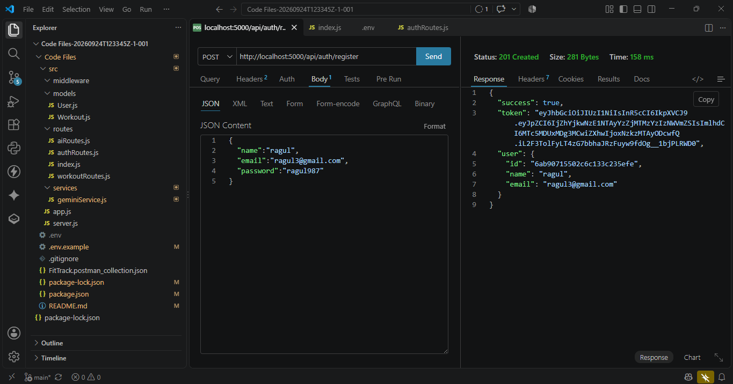

Fig 6.1 — Register API tested in Postman

Login API

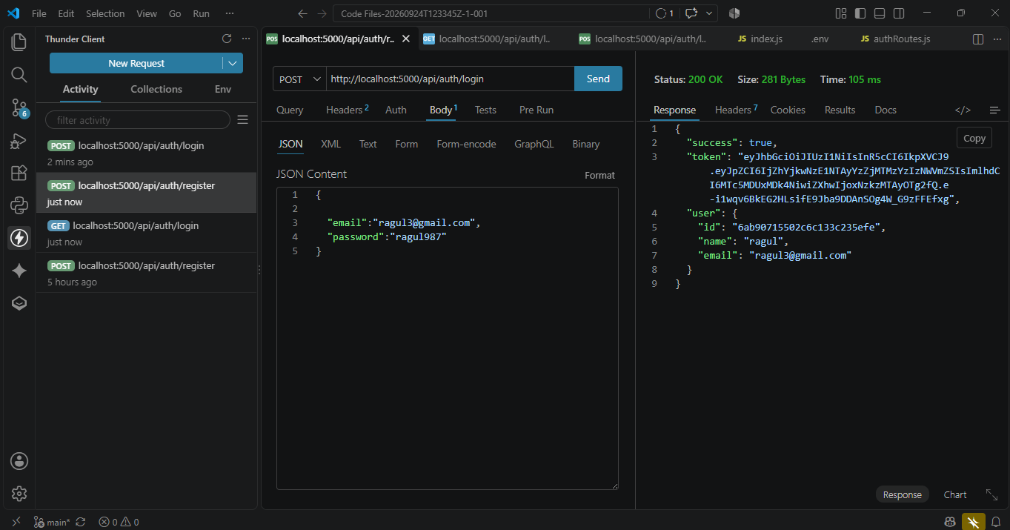
Fig 6.2 — Login API tested in Postman

Workout CRUD API

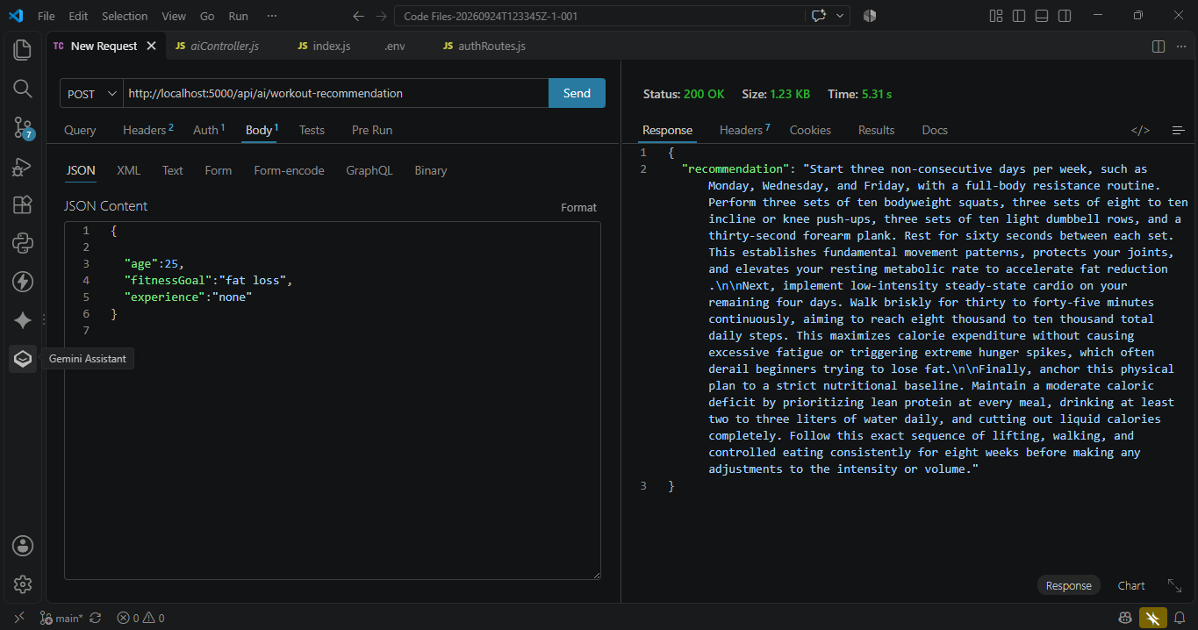

Fig 6.3 — Workout CRUD API tested in Postman

AI Insight API

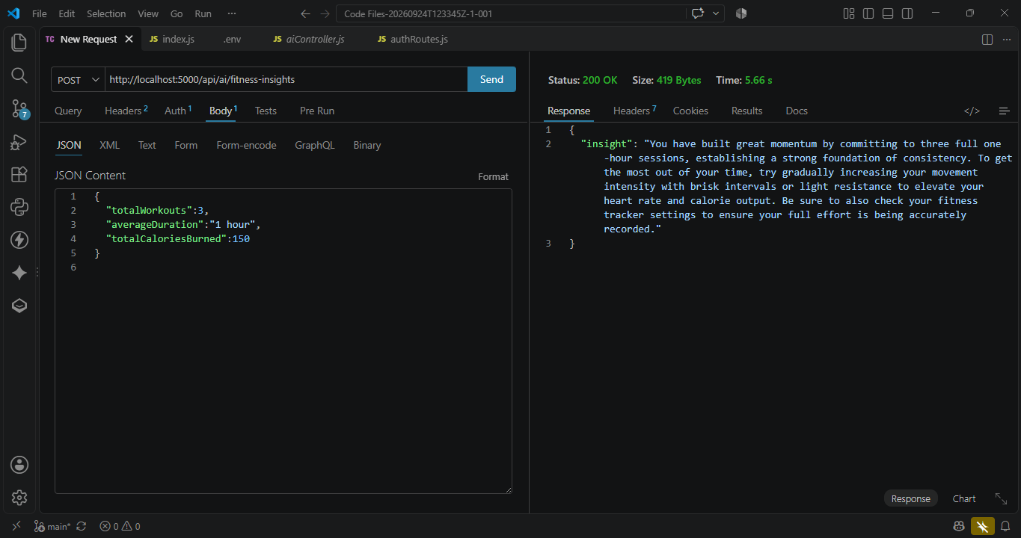
Fig 6.4 — AI Insight API tested in Postman

